An Academic Plan is a recommended sequence of courses based on a student’s academic records and degree requirements. It helps students find their path to academic completion. Students and advisors work together to design an academic plan that is right for the student.

Additionally, students can use their academic plan to create a saved schedule and register for all the classes they need.

Use this reference to view your Academic Plan and to create a Saved Schedule from this plan.

Before you create a Saved Schedule from your Academic Plan, be sure to meet with your advisor to design an Academic Plan right for you. Make sure the courses in your Academic Plan:
- Are available in your preferred academic period
- Do not require prerequisite overrides
- Do not create scheduling conflicts

CREATE A SAVED SCHEDULE from ACADEMIC PLAN

- Log into Workday. From the Academics app, click “Create Saved Schedule from Plan”.

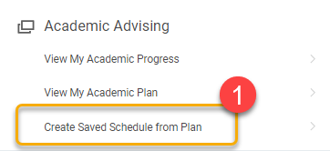

- From the pop-up window, click the Academic Plan field and select your student record.

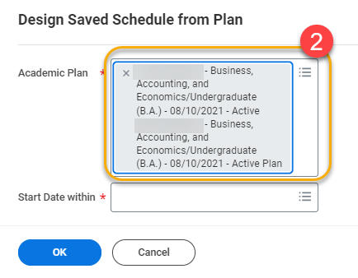

- In the Start Date within field, click the field and select the academic period corresponding to the academic plan from which you want to create a saved schedule.

In this example, the student wishes to create a saved schedule based on the Fall 2024 semester academic plan.

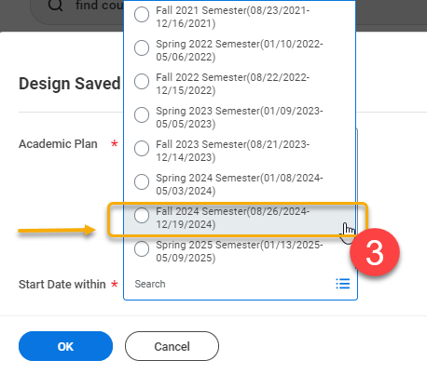

- Click “OK”.

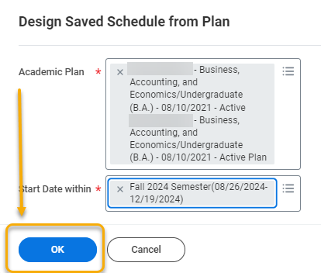

- On the Select Sections for Saved Schedule page, create a name for the new saved schedule.
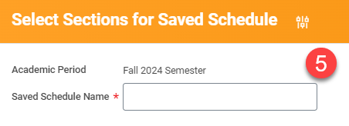

- Scroll down to view the classes in the academic plan on the left-side menu. Proceed to add or remove each course from your new saved schedule. To select a course, click the course name. To add, check the box next to the desired course section. To remove, click the trash can.

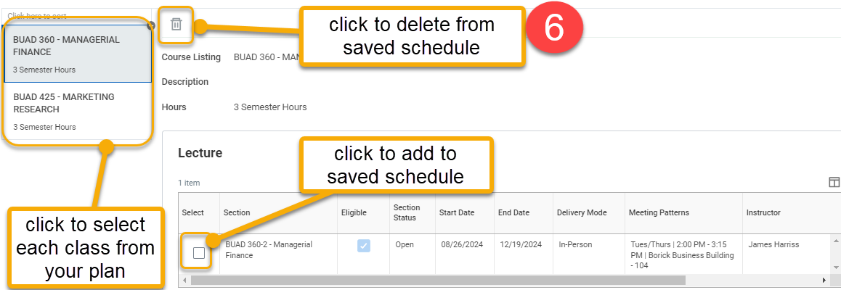

- When finished, click “OK”.


Note: At this point, you may receive errors or alerts. These are usually related to course section eligibility, waitlist, or schedule conflicts. Resolve these before proceeding.

- On the Add Course Section to Saved Schedule page, you have the option to see and print your saved schedule in calendar view or to make additional edits. Do not click the “Add Course” button. This takes you to the entire university catalog.

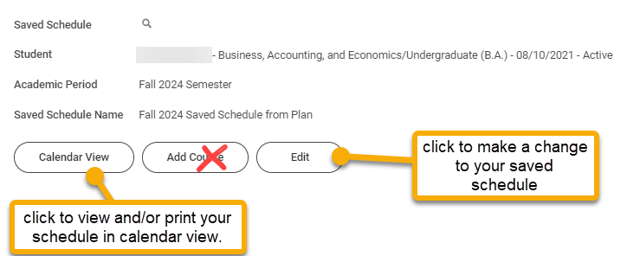

- Click “Done”.


- To view and/or edit this saved schedule on another day, click “View My Saved Schedules” on the Academics homepage.

